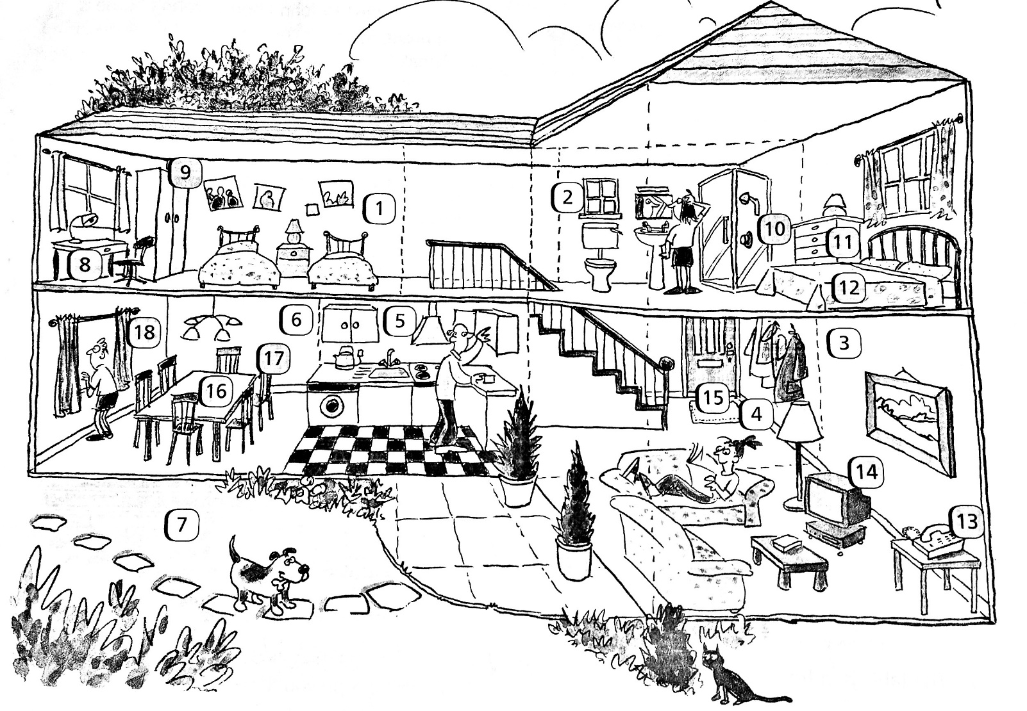
Unit 5 test

1. Napište odpovědi na dané otázky, užijte slovo v závorce.
- Where is the bed? (window)
- It´s under the window.
- Where's the bedside table? (two beds)

- Where's the lamp? (desk)

- Where's the woman? (living room)

- Where's the wardrobe? (desk)

2. Podle obrázku odpovězte na otázky celou větou.
- Is there a cooker in the house?
- Yes, there is.
- Are there two bedrooms in the house?

- Is there a TV in the living room?

- Is there a bath in the bathroom?

- Are there eight chairs in the dining room?

3. Doplňte do věty správné výrazy.
- You cook in the …kitchen
- You have dinner in the …
- You watch TV in the …
- You have a shower in the …
- You go to bed in the …
+ za plusové body:
- you play football in the …
- you park your car in the …

4. Sestavte otázky a odpovězte na ně podle skutečnosti:
- English speak you can ?
- Can you speak English?
- Yes, I can.
- do can where your you homework ?

- your a drive can parents car ?

- do bedroom in can your what you ?

- the can play you guitar ?

- Podle tabulky napište pravdivé věty.

- (Jenny, put up a tent)
- Jenny can´t put up a tent.
- (Nick, dive)

- (Tom, dive)

- (Amanda, swim under water)

- (Jenny, swim under water)

+ Napiš, co vše si dále ještě z této lekce pamatuješ, ale neobjevilo se to v testu:

