Vypracujte test a pošlete do čtvrtka 22. 4. do 18.00
1. Doplň chybějící slovo začínající na dané písmeno:
A/ Meat beginning with a L ………………………………………
B/ Fruit beginning with a G ………………………………………
C/ Drink beginning with a T ………………………………………
D/ Vegetable beginning with a C ………………………………
E/ Fish beginning with a T………………………………………
2. U každého slova napiš buď C – countable nebo U – uncountable:
A/coffee ____ B/ cheese_____ C/ hamburger_____
D/ salt____ E/ egg____, F/ water ____ G/ soup _____ H/ tomato______ I/ Coke ______ J/ fish ______
3. Do otázek doplňte How much nebo How many
A/ _________________ water is in the ocean?

B/________________ meat is in a fridge?

C/_________________ oranges are there?

D/ _________________ bread is eaten per day?

E/__________________ pasta is there?

4. Do vět doplňte a few nebo a little.
A/ There are only ________________ bananas left in the box.
B/ We need _________________ butter for this cake.
C/ The teacher gives us ________________ juice to drink.
D/ There are only _________________ lemons on the fridge.
E/ I bought _________________ milk in this shop.
5. Převeďte nepočitatelná (uncountable) podstatná jména na počitatelná (to countable).
A/ (milk) a bottle of milk
B/ (cheese) _________________________________
C/ (bread) _______________________________
D/ (coke) _______________________________
E/ (tuna) ________________________________
F/ (chocolate) ___________________________
G/ (water) ______________________________
H/ (coffee) _______________________________
6. Doplň a / an / some / any
A/ It is ………………………….. orange.
B/ We didn´t buy …………........... tomatoes.
C/ Are there …………………….. meat?
D/ I need ………………….. apples.
E/ Do you want …………………. fruit?
F/ There is ……………………….. hamburger.
7. Dejte části textu do správného pořadí.
1 ………… 2 ………… 3 …………. 4 …………..
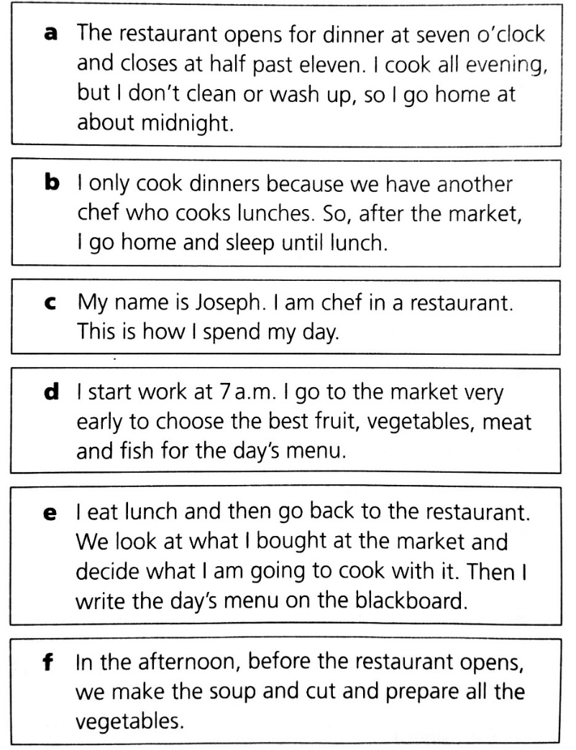
5 ……….. 6 ………….

