19. 10. 2020 Matematika
Práce na doma: Procvičit vzorce
Umocněte podle vzorce: ( a + b )² = a² + 2ab + b²
( o + p )² = ( m + n )² =
( c + d )² = ( k + 2 )² =
( c + 6 )² = ( 6 + c )² =
( k + 4 )² = ( 4 + k )² =
( z + 1 )² = ( p + 3 )² =
( x + y )² = (10 + v )² =
( 12 + a )² = ( h + 11 )² =
( 7 + z )² = ( 1 + w )² =
( 50 + r )² = ( 100 + d )² =
( s + 2 )² = ( 2 + s )² =
( b + 0,25)² = ( 0,2a + 1 )² =
( 0,1c + 0,5 )² = ( 8c + 0,02 )² =
( 3m + p )² = ( 5n + 3 )² =
( r + 7s )² = ( a + 2b)² =
( ab + c )² = ( 9 + 2m)² =
( 3a + b )² = ( 4v + 5 )² =
( 7 + 3m )² = ( z + 5y )² =
( a + 4b )² = ( 3y + 1 )² =
( 7m + n )² = ( 2z + 5 )² =
( 8r + 5 )² = ( 2b + 0,25)² =
(2 + 0, 5a)² = ( -2a - b)² =
( -x - y )² = ( -x – 2y )² =

Umocněte podle vzorce: ( a - b )² = a² - 2ab + b²
( r - s )² = ( r - 6 )² =
( c + d )² = ( k + 2 )² =
( 6 - r )² = ( k - 2 )² =
( k - 4 )² = ( 2 - k )² =
( z - 2 )² = ( p -3 )² =
( x - y )² = (10 - v )² =
( 12 - a )² = ( h - 11 )² =
( 7 - z )² = ( 1 - w )² =
( q - 3 )² = ( 5 - a )² =
( 9 - d )² = ( 8 - u )² =
( 7 - z )² = ( 1 - w )² =
( 50 - r )² = ( 100 + d )² =
( s - 2 )² = ( 2 - s )² =
( b - 0,25)² = ( 0,2a - 1 )² =
( 0,1c - 0,5 )² = ( 8c - 0,02 )² =
( 3m - p )² = ( 5n - 3 )² =
( r - 7s )² = ( a - 2b)² =
( ab - c )² = ( 9 - 2m)² =
( 3a - b )² = ( 4v - 5 )² =
( 7 - 3m )² = ( z - 5y )² =
( a - 4b )² = ( 3y - 1 )² =
( 7m - n )² = ( 2z - 5 )² =
( 8r - 5 )² = ( 2b - 0,25)² =
( 2 - 0, 5a)² = ( -2a + b)² =
Umocněte podle vzorce: a² - b² = (a + b).(a – b)
c² – d² = 4 – k² =
x² – y² = 64x² – 16y² =
49 – 36u² = 9 a²b² – 4c² =
a² - c² = d² - 9 =
4m² - p² = u² - 9 =
25 m² – 16p² = 81 – 144v² =
2x² – 9yz² = p² - q² =
y² - 4 = z² - 36 =
9u² – 16v² = a² b² - c² =
m² – 16 = x² – 9 =
25 – z² = a² – 100 =
49a² – 4b² = 81p² – 4 =
64 – y⁴ = c² – 49 =
100 – 4m² = 0,16r² – 0,04 =
81a² - b² = 16m² – 1 =
= 9x² - 4 y²z² =
(3x – 2) - y² = 9 - a² =
25 v² – 49 = 16 - u² =
t⁴ – 4 = 1 – d⁸ =
w¹² – x¹⁶ = 4 v² – x⁴ =
y² - z⁸ = t² – t⁴ =
n⁶ – 81 = b² - 36 a² =

Kontrola předcházející práce:
- PS 1: str. 66/ cvičení A23 – A26
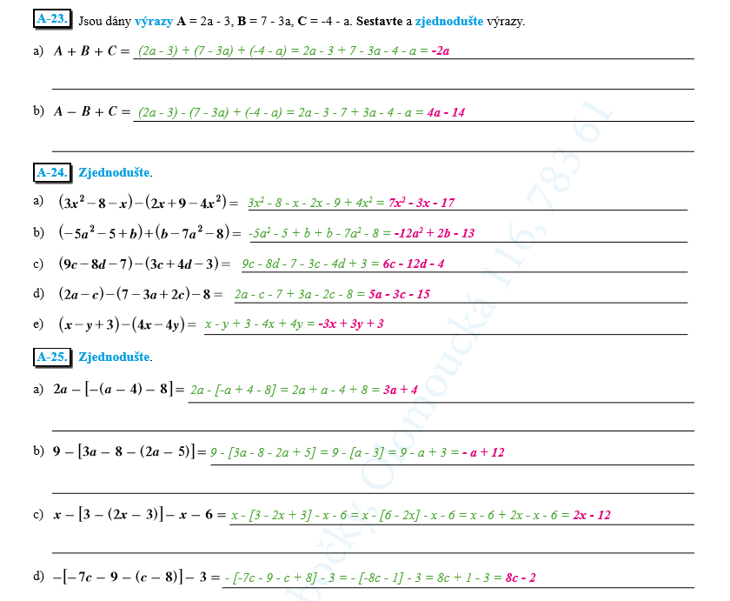

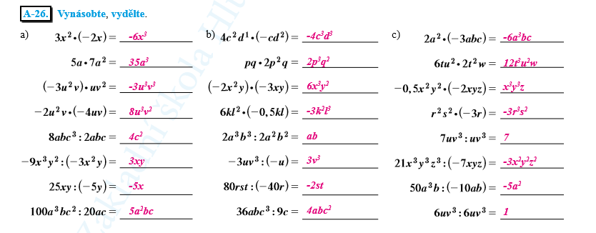

Mgr. Martina Černíková

